BUG report!

Name: ***When you add line 2 in favourite lines, it doesn`t appears***

Type: bug

Priority: high

Enviroment: jsp live apk

**Description :  
When you tap to add bus line “2” in favourite lines , it doesn`t appears in favourite routes field .**

**Steps to reproduce:**

1. **Make internet access**
2. **Open the app store**
3. **In search bar write “jsp live” and download**
4. **Open the “jsp live” apk**
5. **In lines open the bus line “2”**
6. **Tap on the heart**
7. **Open the favourite field**
8. **It doesn`t appears**
9. **In lines open the bus line “4”**
10. **Tap on the heart**
11. **Open the favourite field**
12. **It appears**

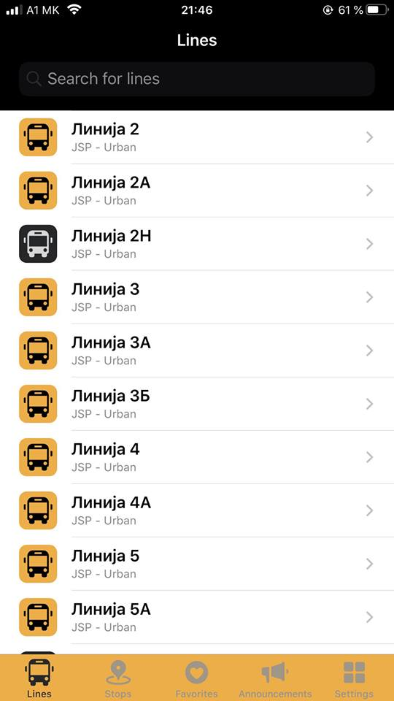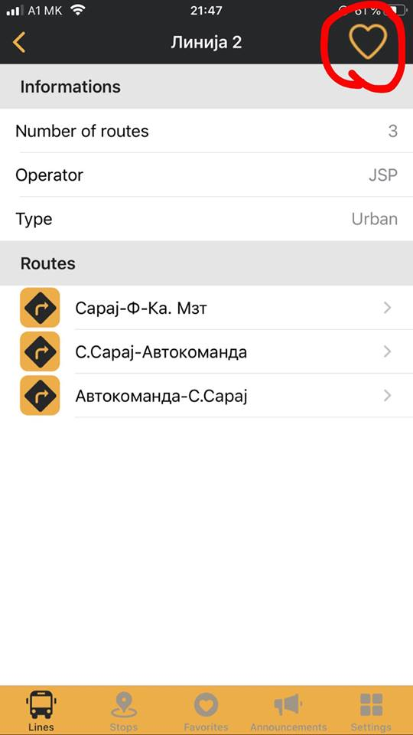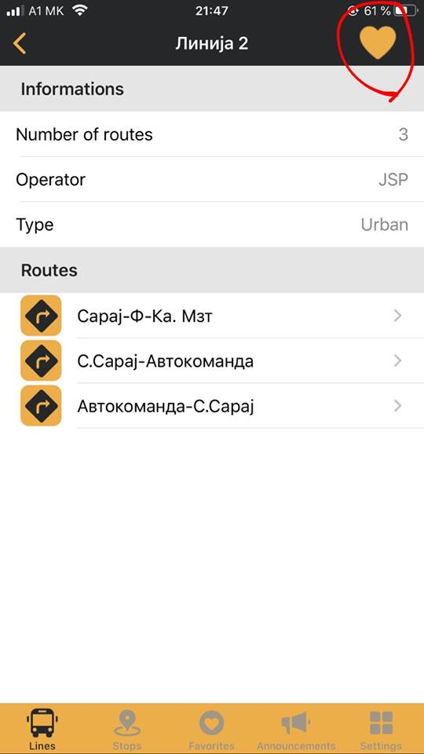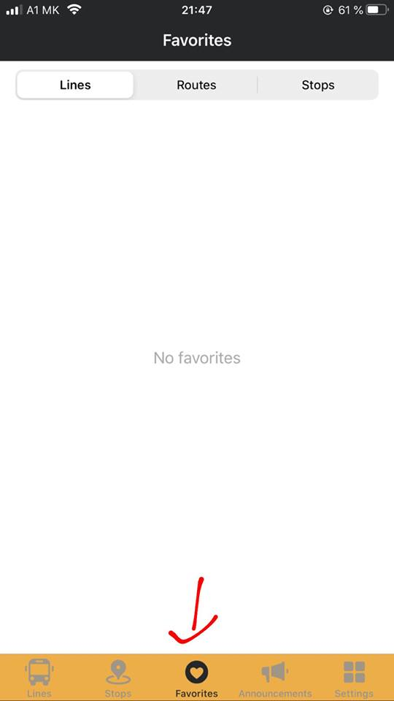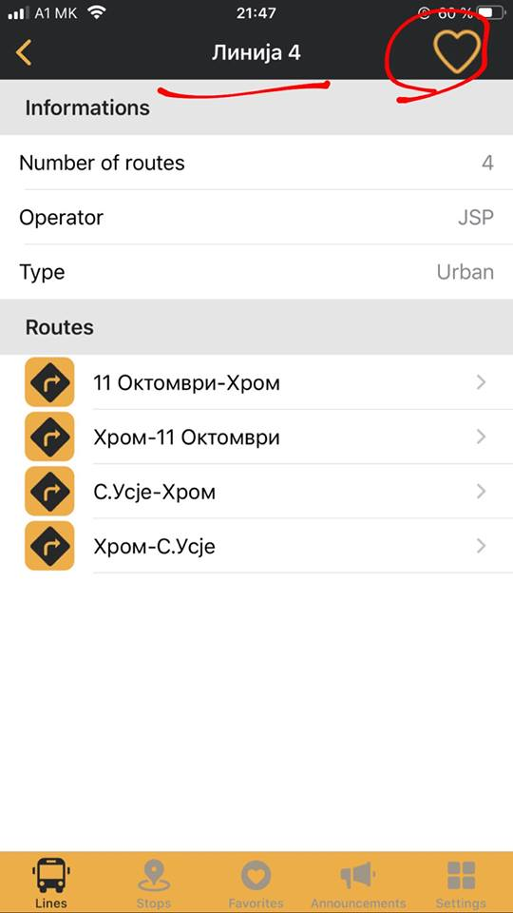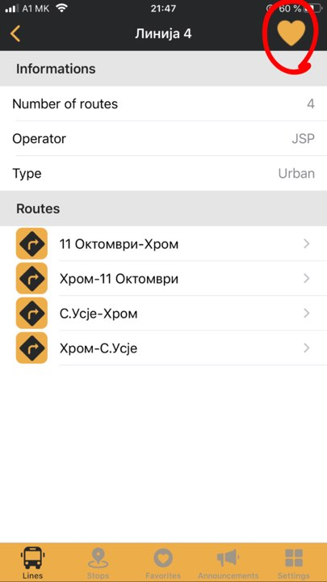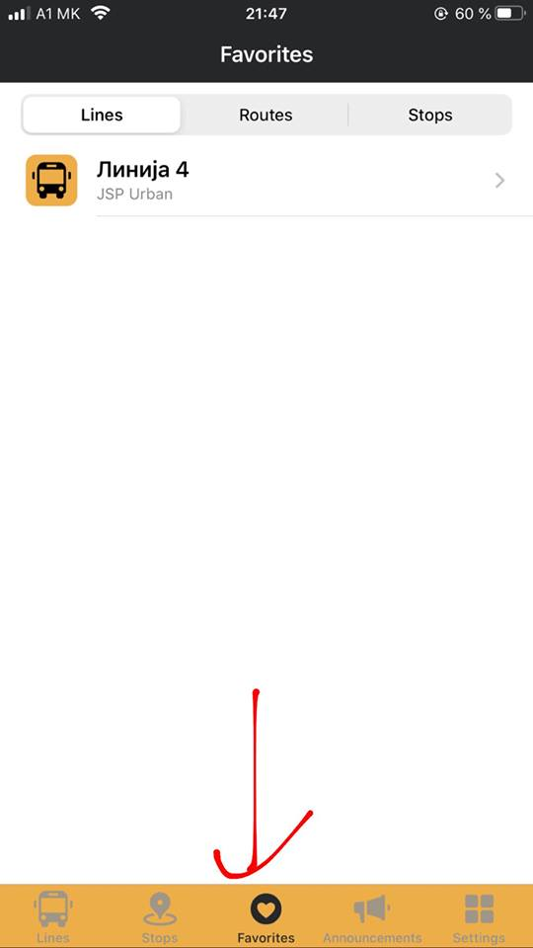

Expected results: When you add bus line “2” in favourite lines it should be appears in favourite lines field.

Report: This was tested on on IOS 13.3 latest version and Android 8.0.0 latest version. On Android 8.0.0 latest version it works good, when you add bus line “2” it appears.

